Scaling Offshore Wind: New Evidence Reveals Hidden Limits to Energy Delivery
Overview of WP4
Researcher: Qi Chen
Professor: Xiaoshu Lu

Overview
Work Package 4 of the InnoWind project focuses on a critical question for the future of renewable energy: how can offshore wind farms be expanded in a way that actually increases usable electricity, not just installed capacity?
At first glance, scaling seems straightforward—adding more turbines or increasing their size should lead directly to more energy. However, the research shows that this assumption does not always hold true in real-world operation. By analyzing a large dataset of turbine measurements, the study identifies a clear gap between the energy that turbines could produce and the energy that is actually delivered to the grid.
This finding reshapes how offshore wind expansion should be understood. Instead of being purely an engineering challenge of building larger systems, scaling is shown to be an operational challenge that depends on wind conditions, turbine behavior, and grid limitations.

A Key Discovery: The “Scaling Gap”
The central finding of WP4 is the identification of what is called the scaling gap—a measurable difference between installed capacity and usable energy output. Using 42,600 high-resolution data points from real offshore turbines, the research shows that increasing turbine capacity does not automatically lead to proportional increases in delivered electricity.
Two main patterns explain this gap. First, most operating time occurs under moderate wind conditions, where power production closely follows natural wind fluctuations. Second, during strong winds—when turbines could produce maximum output—energy production is often limited by external constraints, such as grid capacity.
- 86% of operating time falls below rated wind speed, where output is driven by natural wind variability
- 84.1% of high-wind conditions are limited by curtailment, meaning full capacity cannot be used
These findings demonstrate that much of the available energy is either unstable or restricted, limiting the benefits of simply increasing turbine size or number.

Understanding Where the Limits Come From
The research goes beyond identifying the problem and explains why it happens. By reconstructing real turbine behavior from operational data, two main sources of limitation were identified.
- Variability in Normal Wind Conditions
Most wind farm operation takes place under moderate wind speeds. In this region, power output is not controlled but instead fluctuates directly with changes in wind. This means that when capacity increases, variability also increases. Without better control systems, larger wind farms may become more unstable rather than more productive.
A closer look at turbine control systems shows that while some aspects perform very well, others limit performance:
- Turbines maintain very accurate alignment with wind direction, meaning aerodynamic losses are minimal
- However, power control through blade adjustment (pitch control) is less smooth and limits the ability to stabilize output
- Wind variability dominates most operating hours
- Turbine control systems have limited ability to smooth these fluctuations

- Curtailment Under High Wind Conditions
In strong winds, turbines are capable of generating maximum power. However, the study shows that this potential is often not fully used. Instead, output is frequently reduced due to grid-related limitations. This creates a consistent pattern where turbines operate below their maximum capacity even when wind conditions are ideal.
- Only a small fraction of high-wind periods reaches full output
- Most high-wind energy is limited by grid constraints
This indicates that energy delivery is not limited by turbine performance, but by the system’s ability to absorb and use the electricity.

What This Means for Wind Farm Expansion
The findings clearly show that simply building larger wind farms is not enough. If scaling is not carefully designed, it can increase variability and energy losses instead of improving performance. To address this, the research provides practical design principles for more effective expansion:
- Align turbine design with the most common wind conditions, not just maximum capacity
- Improve control systems to reduce fluctuations during normal operation
- Coordinate wind farm expansion with grid capacity and flexibility
- Reduce curtailment by matching production with energy demand and system limits
In simple terms, future wind farms need to be designed not just to produce energy, but to deliver it reliably and efficiently.

Overall Impact for Offshore Wind Development
The WP4 results provide an important shift in how offshore wind scaling is approached. They show that the main limitation is no longer turbine technology alone, but the interaction between turbines, weather conditions, and the electricity grid.
This has clear implications for planning future wind farms. Without addressing these operational constraints, increasing installed capacity may lead to diminishing returns.
- Installed capacity can grow faster than usable energy output
- Grid limitations and variability are key factors limiting performance
- Better design and coordination are required to unlock full energy potential

Indicators for the InnoWind Project
✅ Identification and quantification of the scaling gap between capacity and output
✅ Large-scale validation using 42,600 real operational data points
✅ Clear evidence that 86% of operation occurs in variable, sub-rated conditions
✅ Quantification of curtailment affecting over 84% of high-wind periods
✅ Identification of control limitations and grid constraints as key bottlenecks
✅ Development of practical design principles for scalable wind farm expansion

Conclusion
The InnoWind WP4 research shows that offshore wind expansion is not just about building more capacity—it is about making that capacity usable.
By revealing the gap between potential and actual energy delivery, and by identifying its causes, this work provides a strong scientific basis for improving how wind farms are designed and operated.
This ensures that future investments in offshore wind lead to real gains in energy production, system stability, and economic value, supporting the broader goals of the InnoWind project.

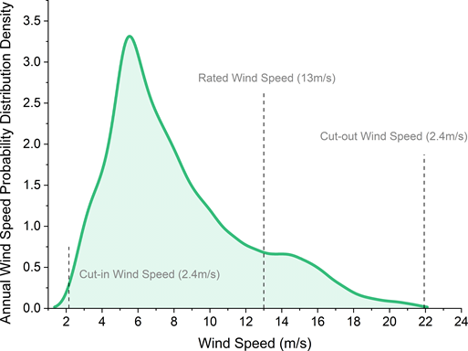
Figure 1: Probability distribution of annual wind speed at the offshore site.

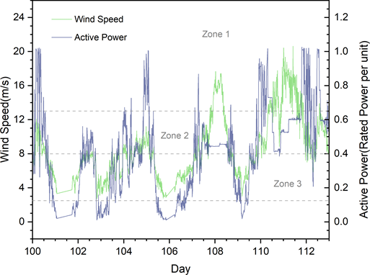
Figure 2: Daily variation of active power and wind speed, illustrating volatility dominance in the sub-rated regime.
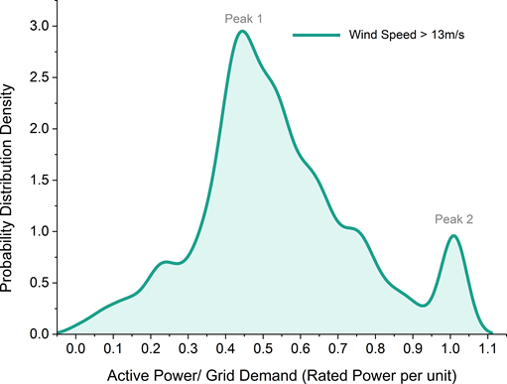
Figure 3: Conditional probability distribution of active power above rated wind speed, showing a bimodal pattern dominated by curtailed operation.
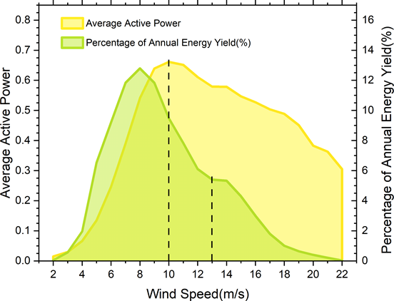
Figure 4: Average active power and the percentage contribution to annual energy yield across wind-speed bins.

Kuvien selitys: Wind-speed distribution analysis (Fig. 1) demonstrates that 86% of annual operation occurs below rated wind speed. In this regime, active power variability (Fig. 2) is directly driven by wind-speed fluctuations. Increasing turbine rating in this dominant regime primarily increases variability exposure unless smoothing capability improves.
Above rated wind speed, the active power distribution (Fig. 3) exhibits a pronounced bimodal structure. The lower plateau corresponds to curtailed operation and accounts for 84.1% of high-wind-speed periods. Only 15.9% of such periods achieve rated output. This structural imbalance quantitatively demonstrates that aerodynamic potential frequently exceeds grid-compatible delivery.
The annual energy contribution analysis (Fig. 4) reinforces this conclusion: most annual energy is generated in the sub-rated regime, while above-rated energy capture is systematically constrained.

